Healthy Schools London Silver Award Case Study

Supporting children’s mental health in light of Covid-19 and lockdowns: Henry Maynard Primary School, Waltham Forest

Due to the recent global pandemic and subsequent lockdown children have faced unprecedented pressures. Although the full impact of this may not yet have been seen, we do know that already that a large number of children who did not present with any mental health issues or worries are now struggling in ways they didn’t before. This school, its leaders, governors and families are all keen to see mental health and wellbeing at the forefront of the return to school and ensuring a recovery curriculum to help children cope with the transition is used.
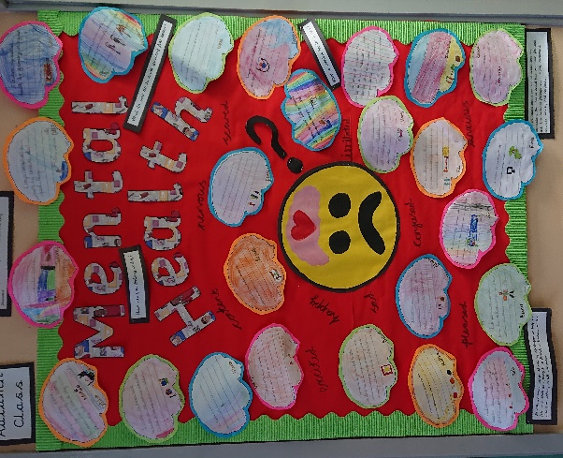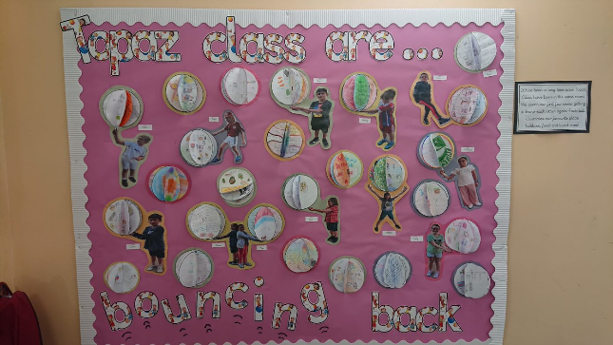

The problem
Children’s mental health is becoming much more of a concern. Research shows that 3 children in every classroom will have a diagnosable mental health disorder and half of adult mental health problems begin before the age of 14, (Children’s Society 2008). When we add to that what some children may have experienced in lockdown e.g. extreme isolation, particularly those children who needed to shield or who were living with shielding relatives, living with adults whose mental health has deteriorated through the isolation or because of financial worries due to being furloughed or made redundant, witnessing care givers abusing drugs or alcohol domestic violence. For some children school can be a safe place and the routine and care that they may not have experienced at home.

The Plan
The school intends to:
- Raise the profile of mental health and wellbeing across the school for both staff and pupils.
- Support the mental wellbeing of staff through clear signposting to where they can get help, or where appropriate providing time and space to speak to their line managers about their worries and concerns. The mental wellbeing of staff has a direct impact on the mental wellbeing of the children in their care.
- Support children’s mental health and wellbeing on their return to school.
- Support children who may be struggling with their mental health
- Develop children and staff’s emotional literacy, to help recognise and understand feelings. This in turn will develop emotional intelligence

The intended outcomes
- Undertake a mental wellbeing survey for all children in the initial weeks of term, which will be repeated later to check that children are feeling more secure and are coping well.
- Observations using the Leuven Scale.
- Complete a mental health and wellbeing survey with staff which will be repeated later in the year to monitor how staff are coping.
- Class teachers will carefully monitor children’s behaviour. Behaviour is used by children as a form of communication and is often the clearest indicator that a child is struggling or not coping with something.
- Monitor discussions with parents about anxiety or other mental health issues being displayed at home. Some children are able to mask anxiety or worries at school which then become uncontrollable at home.
- Children will be confident naming their emotions and understand things they can do to manage them
- Children will report feeling less anxious or worried, have less ‘outbursts of emotion’ or ‘meltdowns’ in school and at home, appear happier and will be able to socialise successfully with their peers.

How they will do this:
- Implement a recovery curriculum for the first two weeks of term.
- This curriculum will be developed around the needs of the children in each individual class but will create and allow opportunities for children to talk about, demonstrate, work creatively to think about and understand their experiences during lockdown.
- Children will be given space to acknowledge and come to terms with some of the loss they experienced during this time, such as loss of friendship, security, routine.
- Develop a whole school ethos on raising awareness of mental health issues.
- Develop a vocabulary of mental health and wellbeing across the school to help children name feelings and understand how to describe and explain them.
- Whole school positive behaviour system where children are constantly praised for what they are doing well to boost esteem
- Whole class discussions about the importance of recognising and experiencing our feelings. Understanding that no feelings are good or bad, but all are important.
- Whole class PSHE lessons and circle time developing a range of strategies children can use to cope when their emotions become too big for them to contain.
- Four learning mentors who are qualified mental health first aiders, will work with both children and staff to help create a supportive environment.
- Where needed they also work closely with parents offering guidance and support and signposting families to additional support that they can access outside of school if necessary e.g. https://www.winstonswish.org/ or offering CAMHS referral

Resources to support Mental Wellbeing
There are many resources and support available to assist discussions relating to mental wellbeing which include:

- Borough Healthy Schools Lead
- School Health Service
- Educational Psychology Consultation Service
- Trailblazers (mental health support teams in schools) or similar support
- Healthy Schools London – Resources to support schools
- PSHE Association: Discussing coronavirus (COVID-19) with children and young people
- PSHE Association: Developing a recovery curriculum webinar
- Health Education Partnership: PSHE and Wellbeing Framework and Resource List
- Health Education Partnership: National and Local Directory of Services
- Health Education Partnership PSHE Booklist
- The Resilient Classroom (Young Minds and Boing Boing)
- Anna Freud – Resources to support children, staff and families
- Anna Freud – Managing the transition back to school: a guide for schools and colleges
- Mentally Healthy Schools: Coronavirus toolkit #6: resources for building resilience
- Healthy London Partnerships – Schools Mental Health Toolkit
- Domestic Abuse Prevention Coordinator
- Child Bereavement UK: Schools information pack
- Child Bereavement UK: Books and resources for primary schools
- Bereavement + Grief PSHE 2020 lesson
- A whole school approach to supporting loss and bereavement, Glasgow City Council
- Mentally Healthy Schools – Coronavirus: resources for mental health and wellbeing toolkit #3
- Mentally Healthy Schools – Coronavirus: mental health and wellbeing resources

https://www.evidenceforlearning.net/recoverycurriculum/
Created by Ferre Laevers in Belgium, the Leuven Scale is a 5-point scale used to measure the wellbeing and involvement of children within an early year setting. Children scoring highly on the Leuven Scale of Wellbeing and Involvement are generally self-confident, engaged in their play and are able to embrace the challenges of their environment.

